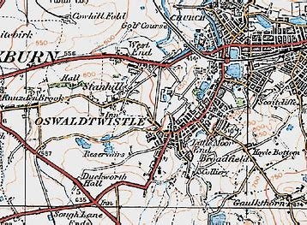
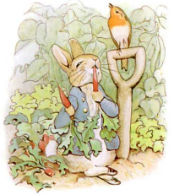
Year 1&2
Spring 2: Learning in …
Science
Science will through-out both Spring 1 and 2, the focus being plants! We will learn how to label a plant, how to keep a plant alive and what it needs for survival, and we will be completing lots of exciting experiments to help with our learning.

We will also be looking at the different seasons, this term we will see both Winter and Spring, exploring the key differences.

English
This half term we are focusing on stories by the same author. The author we will be exploring is Beatrix Potter and her beautiful stories, including Peter Rabbit, Tom Kitten and Jeramiah Duck. We will then move onto poetry on a theme, linking English to Science by using weather as the theme.
The Place That I Live!

History and Geography
We will be focussing on Geography this half term! Our topic will be surrounding the place that we live. We will explore Oswaldtwistle, using maps and ariel shots, to make routes and use a key.
Maths
Maths will see us start with place value to 50! We are now looking at larger numbers, ensuring we understand both the number and problem solving around it. We will then move onto Length, height and capacity.
Computing
Year 1 and 2 will be focussing on Animated stories, using the IPad’s to create our very own moving picture.

P.E
This half term will see us learning how to underarm throw and how to use tactics in a game.

PSHE
Our PSHE topic this half term is money management. We will be discussing where money comes from and how it can be used. We will also explore what budgeting means and how best to do it.

Art and DT
This half term we are focussing on Art. We will explore different types of printing, seeing what we can use to do this and creating our very own printing masterpieces.

R.E
Special Meals
This half term we are looking at Special Meals. We will explore how the Parish family gather for Mass and Jesus’s Special Meal. We will be wondering why people come together or meals and how they do, for example Christmas. We will also discuss who we might feel when celebrating with each other.
Music
This half term we are using KAPOW and focusing on the theme- Superheroes! Within this unit will be explore both pitch and tempo.

