BC | Before Christ. The bigger the number (BC), the longer ago it happened.
AD | ‘Anno Domini’. Used to show dates after the birth of Jesus.
Papyrus | A material like paper used by ancient people to write on
Tomb | A large grave which is above ground with a sculpture or decoration on it.
Hieroglyphics | Pictures used as a form of writing instead of letters.
Pyramid | A building with triangular sides built as an Egyptian tomb (a place to bury the dead).
Source | The cause of something. Where something came from.
Egyptologist | Someone who studies the language and archaeology of Ancient Egypt.
Civilisation | The people in society at a specific place and time.
Mummification | The process of preserving a dead body.
Timeline of relevant history: An introduction to Ancient Egypt: Key Vocabulary:
The Ancient Egyptian Civilisation began 5,000 years ago when people started building villages next to the River Nile in north-east Africa. It lasted for around 3,000 years. The people were ruled by Pharaohs. The river was an important source of water in a hot and dry desert landscape. It enabled the ancient Egyptians to grow lots of crops like wheat, barley, fruit and vegetables. They also grew flax to make clothes. Papyrus also grew along its banks and they used this to write on.
3100BC - 30BC | Egyptian Era
2,640 BC | First pyramid is believed to have been built.
2,520 BC | The Great Sphinx (body of a lion and head of a human) is believed to have been built.
1, 332 BC | The 10- year rule of Tutankhamun begins.
55-54 BC | Julius Caesar leads two Roman military expeditions to Britain but was driven back by the Celts on both occasions.
51 BC | Queen Cleopatra’s reign begins. She is the last Pharaoh of the ancient Egyptian period.
43 AD | Romans invade Britain.
1922 AD | Howard Carter discovers the tomb of Tutankhamun in the Valley of the Kings.
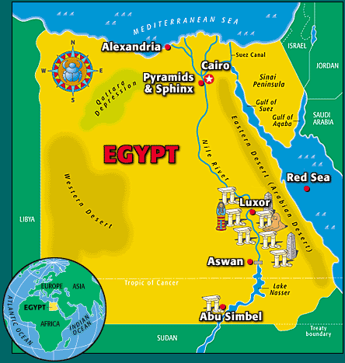
Where is Egypt?
Cairo is the capital of Egypt. The River Nile is the longest river in the world. People settled near the Nile. This is because it is green, and crops can be grown in the areas around the Nile whilst the rest of Egypt is desert. The people of ancient Egypt depended on the Nile to survive.

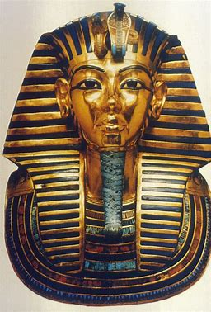

What are Hieroglyphics? Tutankhamun: Religion:
The Ancient Egyptians believed in many gods and goddesses who ruled different aspects of their lives. Egyptians believed in never-ending afterlife. Some gods carried an ankh (a symbol of life) and some gods carried a sceptre of power.
Tutankhamun reigned for approximately 10 years. He died around the age of 18 and was buried in a tomb in the Valley of the Kings. His burial place was hidden for many centuries. It was discovered by the Egyptologist Howard Carter in 1922. It contained many amazing artefacts, including Tutankhamun’s famous golden death mask, a chariot and a dagger made from meteorite iron!
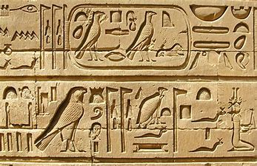
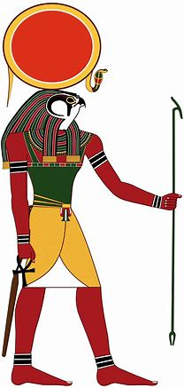
Hieroglyphs The ancient Egyptians invented a writing system using symbols called hieroglyphs, which comes from a Greek word meaning ‘sacred carving’. This is because they believed that hieroglyphs had been invented by the gods.

 | Osiris | Sekhmet | Ra
Role | God of the dead and leader of the underworld | Goddess of healing | God of the Sun
Appearance | A mummified man wearing a white cone-like headdress with feathers | Woman with the head of a lioness | Man with hawk head and headdress with a sun disk.

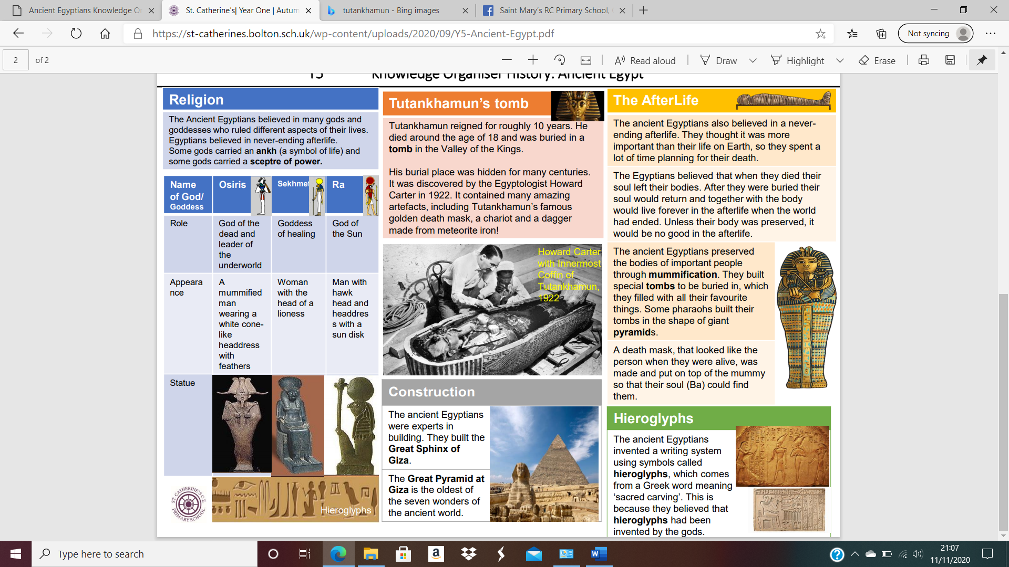
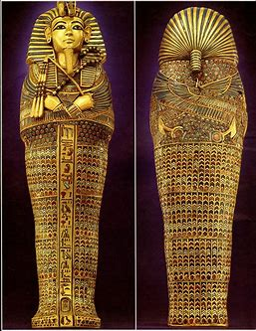
The Afterlife:

Statue
The Egyptians had a strong belief in the afterlife. The ancient Egyptians preserved the bodies of important people through mummification. They built special tombs to be buried in, which they filled with all their favourite things. Some pharaohs built their tombs in the shape of giant pyramids.
A death mask, that looked like the person when they were alive, was made and put on top of the mummy so that their soul (Ba) could find them
Did you know?
The Egyptians were experts in building. They built the Great Sphinx of Giza. The Great Pyramid at Giza is the oldest of the seven wonders of the ancient world.

