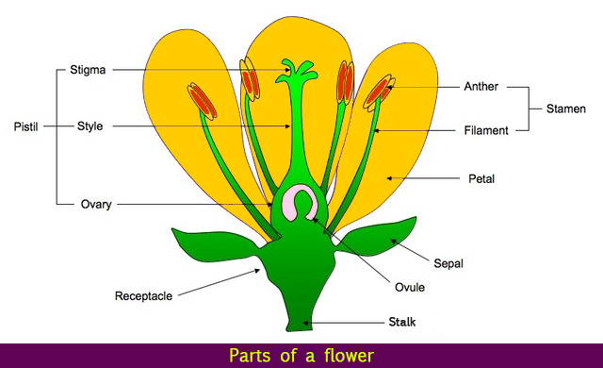
Key Vocabulary
Amphibian – A cold-blooded vertebrate animal that compromises frogs, toads, newts, salamanders and caecilians.
Asexual reproduction – Offspring get genes from one parent so are clones of their parents.
Bird – A warm-blooded egg-laying vertebrate animal distinguished by the possession of feathers, wings, a beak and typically able to fly.
Habitat – The natural home or environment of an animal, plant or other organism
Insect – A small animal that has six legs and generally one or two pairs of wings.
Invertebrate – An animal lacking a backbone.
Life cycle – The series of changes in the life of an organism including reproduction
Mammal – A warm-blooded vertebrate animal, distinguishable by the posession of hair or fur, females secreting milk for young and typically giving birth to live young.
Metamorphosis – The process of transformation from an immature form to an adult form in two or more distinct stages.
Sexual reproduction – Offspring get genes from both mum and dad, inheriting a mix of features from both
Vertebrate – An animal with possession of a backbone/ spinal column

Living Things and their Habitats

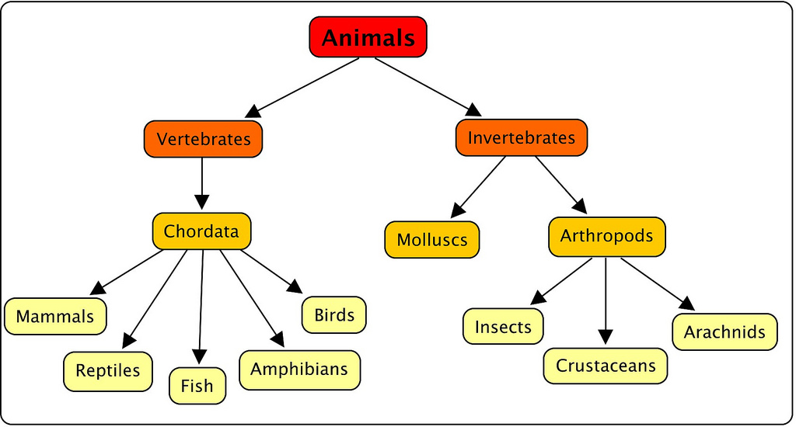
Classification

