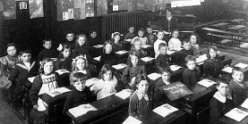
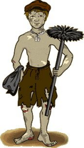
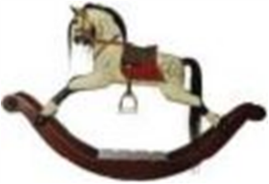
The period of time between 1837 to 1901 when Queen Victoria reigned over Britain. During her 63-year reign, there was a huge contrast between how the rich and poor Victorians lived. Queen Victoria led the expansion of the British empire and saw major changes to all aspects of Britain due to exciting discoveries and inventions.
School
Start: 9 am End: 5pm
Lessons: Drill Exercise, Reading, Writing, Arithmetic, Bible Study, Sewing (Girls), Woodwork/ Gardening (Boys).
School rules
Pupils must wait permission to speak
Pupils must use right hand
Pupils must stand when adults enter
Pupils must not ask questions
Pupils must not raise their hands without permission
Talking and fidgeting will be punished
Punishments
The Cane (hands or bottom), Dunce’s hat, Lines.
Equipment
Slate, Slate Pencils, Abacus, Globe, Ink (Older children), Blackboard.
Extra Information
Wooden desks– fixed to floor
High windows
Up to 100 children per class
Strict teachers (usually female)
Bare walls

Government Reforms
1842 – Mines Act stopped women and children under 10 working in mines
1844 – Factory Act stopped children between 8-12 from working more than 6½ hours a day
1847 – Factory Act limited women and children under 18 to a 58-hour working week
1864 – Boys under 10 were banned from being chimney sweeps
1874 – Ten Hour Factory Act meant that people could not be made to work for more than 10 hours a day and children under 14 could not be employed fulltime
1878 – Factory and Workshop Act banned the employment of children under 10
1880 – Education Act made it compulsory for children up to 12 to go to school, but most children had to pay
1891 – Education is free and compulsory for all 5-13 year olds
Children’s jobs
Farm work
Trade apprentice– Butcher, Baker, Funeral Parlour etc.
Chimney Sweep
Factory worker– cleaning machinery
Trapper– Open and shut doors in mines to allow release of gases.
Drawer– Pull carts of coal by a chain around their waist out of the mines.
Street Children
Run Errands
Shoe shine
Sweep streets in front of the rich
Begging
Stealing
Selling: Flowers, Matchsticks, Boot laces, Buttons, Firewood.

Poor Home Life
Small houses– 1/2 rooms
Sometimes shared with families
Slums– dirty houses packed together
Very little food
Worn, dirty clothes
Open sewer
Water pumped from a well
Shared toilet
Invent own games
Play with what you find
Involved with housework
Closer with parents
Rich Home Life
Large houses
Servants/Maids/Nanny/Tutor
Expensive Clothes
One hour a day with parents
Flushing Toilets
Running Water
Nice food– sandwiches, meats, jams, sweets etc.
Expensive toys– Rocking horse, Doll’s house, Cuddly Toys.
Sea side holidays
Strict routines
Scared of parents
Inventions
1840– Stamps
1843– Christmas Cards
1846– Sewing Machine
1849– Concrete
1851– Ice Cream
1852– Flushing Toilet
1854– Steel Production
1872– Penny Farthing Bicycle
1873– Typewriter
1876– Telephone
1977– Phonograph (Record Player)
1878– Electric Street Lighting
1885– First Motorcar
1888– Kodak Camera
1894– Moving Pictures (Films)
Key Words
Urban– Town environment
Slum– Poor housing area
Orphan– Child with no parents
Workhouse– Home for the poor
Cane– Stick used for punishment
Abacus– Used for calculating sums
Factory– Building with machines
Governess/Tutor– Home teacher
Nanny– Raises rich children
Time period:
1837– 1901
Monarch: Queen Victoria

The Victorian Era Knowledge Organiser

