HANDWRITING POLICY

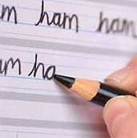
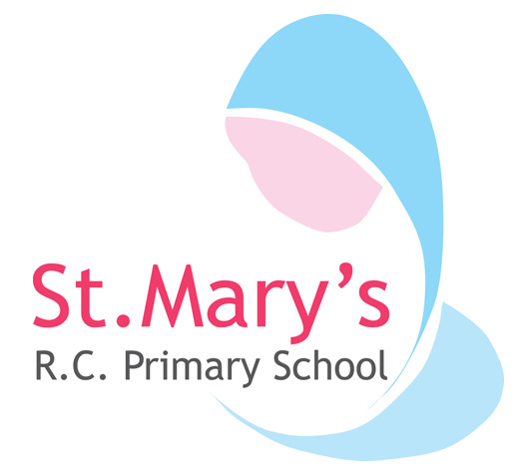

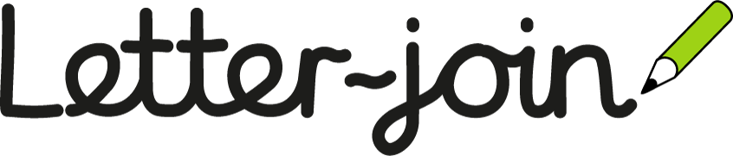

St. Mary’s RC Primary School Mission Statement
• We will always open our doors wide in welcome.
• We will always love and care for each other as Jesus taught us.
• We will always place the Word of God at the heart of our School.
• We will always worship God our Father.
• We will always be witnesses to Jesus Christ by following in his footsteps.

Written by: Lois Quinn
Date written: September 2024
Approved by governors on: October 2024
Policy will be reviewed: September 2026, or sooner if changes are made to legal requirements.
At Saint Mary’s Primary School, we are very proud of our pupil’s handwriting and take particular care in our cursive handwriting style. We use Letter-join’s on-line handwriting resource and progression as the basis of our handwriting policy as it covers all the requirements of the
National Curriculum and builds fluency and stamina for writing. The children can access Letter-join both in school and at home which reinforces letter and number formations taught at each phase and the phonics and the statutory spellings and grammar for all year groups.

Objective
Handwriting is a basic skill that influences the quality and quantity of written work throughout the curriculum. By the end of Key Stage 2 all pupils should have the ability to produce fluent, legible, joined-up handwriting, and to understand the different forms of handwriting used for different purposes. Our intention is to make handwriting an automatic process that does not interfere with creative and mental thinking.

Aims:
- To build fine and gross motor skills needed to develop early letter formation in a fun and engaging way.
- To develop a neat, legible, handwriting style using continuous cursive letters, which leads to producing letters and words automatically in independent writing.
- To establish and maintain high expectations for the presentation of written work.
- For pupils to understand, by the end of Year 6, the importance of neat presentation and the need for different letterforms (cursive, printed or capital letters) to help communicate meaning clearly.

Expectations
To ensure consistency throughout the school, all teaching staff are encouraged to model the cursive style in all their handwriting, including whiteboards, modelled writing or when giving feedback in pupils’ books. Wherever possible, worksheets should also be in cursive script and used minimally to encourage children’s writing.
Pupils should experience coherence and continuity in the learning and teaching of handwriting across all school years and be encouraged to take pride in the presentation of their work. Our objective is to help pupils enjoy learning and developing their handwriting with a sense of achievement and pride.

Pens and pencils
Children will start handwriting using a soft pencil. When fine motor skills have been established and children have been taught how to join all letter families and use this consistently within all written work, a handwriting pen will be given to children.

Inclusion
For children who experience handwriting difficulties due to fine motor development, including those who are left-handed or those with special educational needs, the appropriate additional support will be put into place.

Correct Posture and Pencil Grip for Handwriting
Pupils should be taught to sit correctly at a table, holding a pencil comfortably and correctly.

Sitting Position

The table reaches to below elbow

Keep feet flat on the floor
Sit with a straight back, not leaning over the page

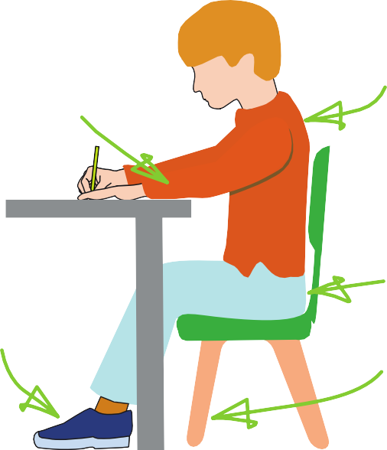
Sit right back in the seat

Pull the chair close in to the table

Paper position for right-handed children.

Left Handed Children
Left-handed children may find it difficult to follow the movements of right-handed teachers as they model letter formation (and vice versa). Teachers should demonstrate to left-handers on an individual or group basis.
- Left-handed pupils should sit to the left of a right-handed child so that they are not competing for space.
- Pupils should position the paper/book to their left side and slanted, as shown.
- Pencils should not be held too close to the point as this can interrupt pupils’ line of vision.
- Extra practice with left-to-right exercises may be necessary before pupils write left-to-right automatically.

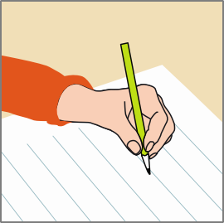

Paper position for left-handed children.

The Tripod Pencil Grip
Both right and left handed children should be encouraged to use the tripod grip which allows the pen/pencil to be held securely whilst allowing controlled movements of the pen/pencil nib. We use
the Tripod Grip Rhyme:

Right-handed pencil grip
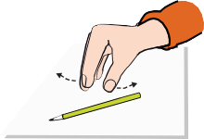
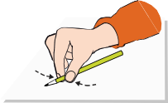
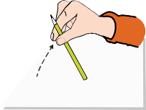
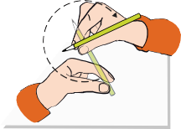
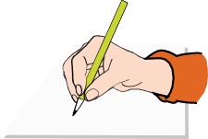
Point away the pencil, Pinch it near the tip, Lift if off the table, Spin it round... and grip.

Left-handed pencil grip
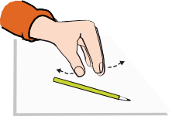
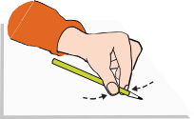
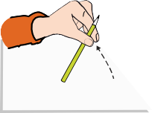
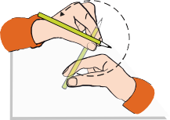
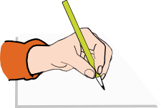
Point away the pencil, Pinch it near the tip, Lift if off the table, Spin it round... and grip.

Phase Expectations for Handwriting Early Years
For our youngest pupils we teach short handwriting lessons on a daily basis. Lessons will include;

- enhancing gross motor skills such as air-writing, pattern-making and physical activities
- exercises to develop fine motor skills such as mark-making on paper, whiteboards, sensory trays, iPads, tablets, etc.
- becoming familiar with printed letter shapes, their sounds, formation, and vocabulary linked to letter families
- correct sitting position and pencil grip for handwriting
Our handwriting expectations are in line DFE and EEF Guidance that states; ‘Accurate letter formation is an essential early skill that forms the basis of a fluent handwriting style. There is no quick way to develop these essential skills other than through regular and substantial practice.’

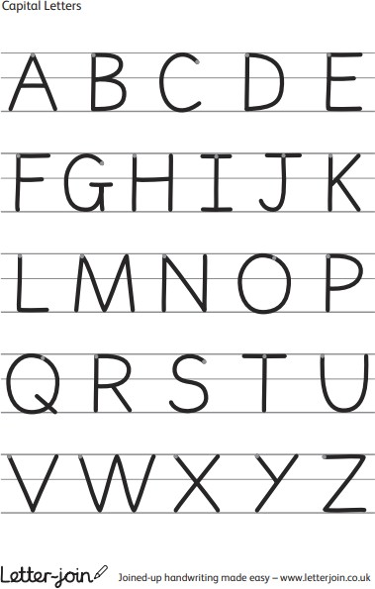
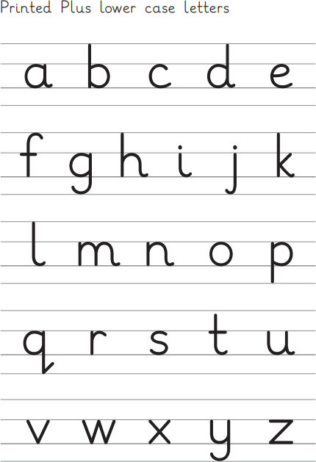
By the end of Early Years Foundation Stage all children should be able to recognise and form correctly all printed uppercase and lowercase letters of the alphabet from the correct starting point so they are Year 1 ready.
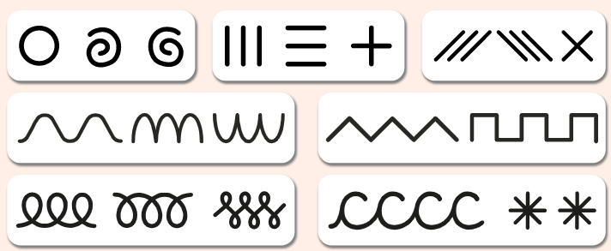

Key Stage 1: Years 1 and 2
In Key Stage 1, we teach at least three discreet handwriting lessons per week, which build on children’s starting points to develop fully cursive joined up writing.
Lessons will include;
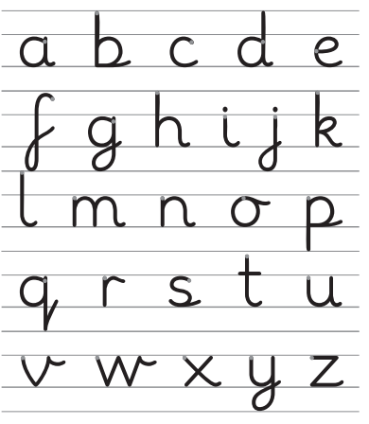
- continuing with gross and fine motor skills exercises
- learning cursive through letter families
- revisiting numerals, capitals and printed letters; where and when to use the lead in, learning and practice
- knowing high frequency words
- dictation exercises
- strengthening cursive handwriting, learning and practice
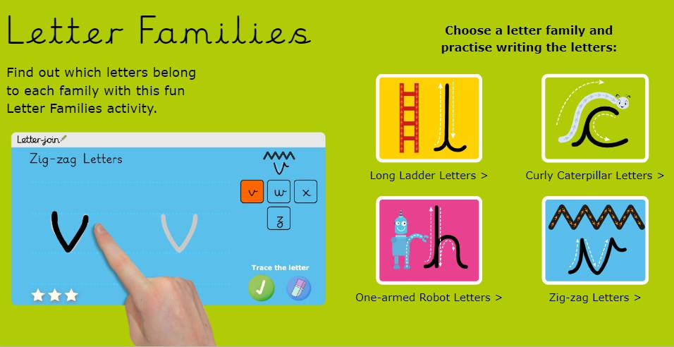
- KS1 SATs Spelling, Punctuation and Grammar exercises

With the regular handwriting practice throughout Key stage 1, children will develop the fluency and speed of their writing to ensure it becomes automotive and that they have the stamina to achieve well in lessons and meet age related expectations.

Key Stage 2:
Handwriting lessons will continue in Lower Key Stage 2 and only as needed in Year 5 and 6. Children should be using a cursive style throughout their independent writing in all subjects, helping to refine their handwriting in line with the requirements of each lesson.
The focus of handwriting lessons will be to build fluency and consistency and will support other key areas of the curriculum for example statutory spellings and aspects of grammar and punctuation.
Lessons may include;
  - exercises linked to spelling, grammar and punctuation for year group expectations
  - reinforcement and practice of cursive handwriting joins
  - dictation exercises promoting quick note-taking and speedy handwriting writing skills
  - redrafting of writing for moderation
  - KS2 SATs Spelling, Punctuation and Grammar practice
By the end of Key Stage 2 all children will have been given the opportunity to develop the stamina and skills to write at length in a given time frame, with accurate spelling and punctuation. They will be able to work towards producing consistently neat and well-presented handwriting in all curriculum subjects. Children should be producing cursive writing automatically, without thought,
enabling them to focus on the content of their work rather than the process of writing so that they can achieve well in lessons and meet age related expectations for Year 6.

Handwriting at Home
Parents can support their children’s handwriting at home by using the Pupil log-in for Letter-join provided below;

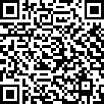
Tablet log-in
User name: qr7433
Swipe code: A capital 'L' shape starting at top left.

PC log-in
User name: qr7433
Account Password: home

Children can watch the word and letter animations and practice and explore other handwriting resources on Letter-join including;
- Magic Patterns
- Magic Words
- Phonics Match
- Word Search
- Word Bank
- Write it Right!
There are lots interactive and engaging activities for all year groups to support letter formation, cursive handwriting and spelling, grammar and punctuation.

Members of staff responsible: Lois Quinn (English Lead) Pamela McGarry (Phonics Lead)
Date Policy written: September 2024
Date approved by the full Governing body; October 2024
Date to be reviewed; September 2026, or sooner if changes are made to legal requirements.

