 | AUTUMN | SPRING | SUMMER
CORE TEXT(s) or FILM PIECE | Kensuke’s Kingdom, Michael Morpurgo  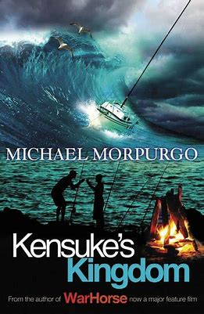 | Short Film- La Luna, Disney Pixar  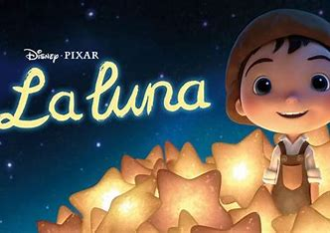  Classic/Older Literature  The Jungle Book, Rudyard Kipling  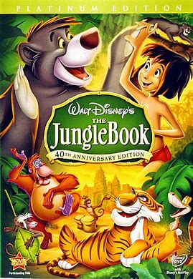 | Greek Myths and Legends  A variety of myths and legends from Ancient Greece  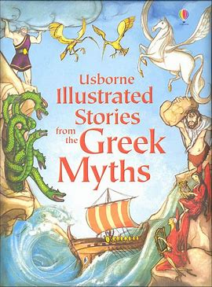  Macavity the Mystery Cat, TS Elliot  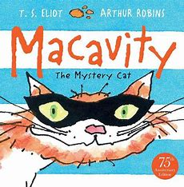
NARRATIVE
NARRATIVE – unit and skills | Stories with historical settings (Year 4). Novels and stories by significant children’s authors (Year 5)  Writing skills:  - Create complex sentences by using relative clauses with relative pronouns who, which, where, whose, when, that  - Use commas, brackets and dashes to indicate parenthesis  - Effectively use pronouns.  - Link ideas across paragraphs using adverbials for time, place and numbers  - Use devices to build cohesion within a paragraph  - To use bullet points, colons and semi-colons when writing lists.  - To use a variety of conjunctions to write more complex sentences.  - Use expanded noun phrases to convey complicated information concisely.  - Proofread for spelling and punctuation errors.  - Create complex sentences with adverb starters.  - Use commas to mark clauses in complex sentences.  - Create sentences with fronted adverbials for when and where.  - Use a comma after fronted adverbials.  - Use the correct determiners.  - Use inverted commas and other punctuation to indicate direct speech.  - Use apostrophes for singular and plural possession. | Plays (Year 4 and Year 5) - La Luna, Disney Pixar  Film narrative, The Jungle Book (Year 5)  Writing skills for La Luna:  - Demarcate complex sentences using commas and explore ambiguity of meaning.  - Identify and use brackets and dashes.  - Use inverted commas and other punctuation to indicate direct speech.  - Identifying the audience and purpose.  - Select the appropriate language and structures.  - Note and developing ideas.  - Think how authors develop characters and settings in films and performances.  - Assess the effectiveness of own and others’ writing in relation to audience and purpose.  - Suggest changes to grammar, vocabulary and punctuation to enhance effects and clarify meaning.  - Proofread for spelling and punctuation errors.  - Use apostrophes for singular and plural possession.  Writing skills for Jungle Book:  - Explore, collect and use modal verbs to indicate degrees of possibility e.g. might, could, shall, will, must, maybe, perhaps etc  - Use devices to build cohesion within a paragraph e.g. firstly, then, presently, this, subsequently.  - Use expanded noun phrases to convey complicated information concisely, e.g. carnivorous predators with surprisingly weak jaws and small teeth.  - Link ideas across paragraphs using  - adverbials for time, place and numbers e.g. later, nearby, secondly.  - Create complex sentences where the  relative pronoun is omitted e.g. Tina,  standing at the bus stop, pondered the day ahead.  - Create and punctuate complex sentences using ed opening clauses e.g. Exhausted from the race, Sam collapsed in a heap.  - Create and punctuate complex sentences using ing opening clauses, e.g. Grinning with anticipation, Paul launched himself from the diving board.  - Create and punctuate sentences using simile starters.  - Identify the audience and purpose.  - Select the appropriate language and  - structures.  - Use similar writing models.  - Note and develop ideas.  - Draw on reading and research.  - Think how authors develop characters and settings (in books, films and performances).  - Select appropriate structure, vocabulary and grammar.  - Blend action, dialogue and description within and across paragraphs.  - Use different sentence structures with increasing control (see VGP).  - Use devices to build cohesion (see VGP).  - Proofread for spelling and punctuation errors. | Traditional stories, fables, myths, legends (Year 5)  Macavity, classic, narrative poem (Year 4 and 5).  Writing skills for Greek myths:  - Identify the audience and purpose.  - Select the appropriate language and structures.  - Use similar writing models.  - Note and develop ideas.  - Assess the effectiveness of own and others’ writing in relation to audience and purpose.  - Suggest changes to vocabulary and to enhance effects and clarify meaning.  - Proofread for spelling and punctuation errors.  Writing skills for Macavity:  - To identify relative clauses in sentences.  - To add relative clauses to sentences.  - To write reported and direct speech, correctly punctuated.  - Identify the audience and purpose.  - To select the appropriate language and structures.  - To use similar writing models.  - To note and develop ideas.  - To draw on reading and research.  - To think how authors, develop characters and settings (in books, films and performances).  - To select appropriate structure, vocabulary and grammar.  - To blend action, dialogue and description within and across paragraphs.  - To use different sentence structures with increasing control (see VGP).  - To use devices to build cohesion (see VGP).  - To use organisation and presentational devices  e.g. underlining, bullet points, headings.  - To ensure consistent and correct use of tense  - throughout a piece of writing.  - To ensure consistent subject and verb agreement.  - To proofread for spelling and punctuation errors.
Scaffolded Purpose | Purpose:  To write a summary of the beginning and middle of Kensuke’s Kingdom. | Purpose:  To write the short film as a play script.  To write a diary account. | Purpose:  To write a letter as Pandora.
Independent Purpose and Audience | Purpose:  To write an alternative ending.  Audience:  Read to peers within class. | Purpose:  To write a sequel play script where the characters’ travel to Mars.  To write a sequel for the Jungle Book.  Audience:  Share with parents on Seesaw.  Read to another class. | Purpose:  To write a letter to Pandora.  Audience:  Read to peers within class.
Narrative  Weekly short independent writing opportunities within the unit | - Balanced argument  - Write from the perspective of the orang-utan or Kensuke  - Missing person poster  - Message in a bottle  - Simile poem  - Description of the island, Kensuke’s cave and a scary situation  - Character description | La Luna  - Write from a different perspective  - Write a diary  - Write part of the play as dialogue  - Describe characters and settings  Jungle book  - Describe characters and settings  - Create their own characters  - Create a story map for their story  - Diary entries | - Character study and descriptions using similes and metaphors  - Focusing on motives, thoughts and feelings.  - Sequencing events in myths.
Non-fiction
Non-fiction  Unit and skills | Instructions (Year 5) Remembrance day, how to make a poppy wreath/cross  Explanations - (Year 4 and 5), Christmas during WW1  Writing skills:  - Use apostrophes for singular and plural possession e.g. the dog’s bone and the dogs’ bones.  - Identify and discuss the purpose, audience, structure, vocabulary and grammar of narrative, non-fiction and poetry.  - Generate and select from vocabulary banks.  - Use different sentence structures.  - Use paragraphs to organise writing in fiction and non-fiction texts.  - Link ideas across paragraphs using fronted adverbials for when and where e.g. Several hours later…, Back at home… | Information texts (Year 4) on planets  Explanation and persuasive texts (Year 4 and 5)  Writing skills:  - Demarcate complex sentences using commas and explore ambiguity of meaning.  - Identify and use brackets and dashes.  - Identifying the audience and purpose.  - Select the appropriate language and structures.  - Note and developing ideas.  - Think how authors develop characters and settings in films and performances.  - Assess the effectiveness of own and others’ writing in relation to audience and purpose.  - Use organisational and presentational devices e.g. underlining, bullet points, headings.  - Suggest changes to grammar, vocabulary and punctuation to enhance effects and clarify meaning. | Olympic Games, Report (Year 5) into the start of the Olympic games  Recounts: newspapers/magazines (Year 4) linked to Macavity  Writing skills:  - Identify the audience and purpose.  - Select the appropriate language and structures.  - Use similar writing models.  - Note and develop ideas.  - Assess the effectiveness of own and others’ writing in relation to audience and purpose.  - Suggest changes to vocabulary and to enhance effects and clarify meaning.  - Use paragraphs to organise writing in fiction and non-fiction texts.  - Use organisational and presentational devices e.g. underlining, bullet points, headings.
Scaffolded Purpose | Purpose: To write instructions how to make a poppy.  To write a newspaper report on the Christmas Truce. | Purpose:  To write a factual description of a planet.  Scaffolded outcome and independent are different. Children should learn the writing skills for their independent piece through the scaffolded. | Purpose: To write a leaflet about the Olympic games.  A newspaper report about one of Macavity’s crimes.  Scaffolded outcome and independent are different. Children should learn the writing skills for their independent piece through the scaffolded.
Independent Purpose and Audience | Purpose: To write instructions how to make a poppy wreath.  To write a newspaper report on Christmas Day during WW1, home and on the field.  Audience:  Share with a KS1 class. | Purpose:  To invent own planet and persuade people to visit it.  Audience: Make a class brochure of planets to visit. | Purpose: To write a factual story about visiting the Olympic games.  A newspaper report on Macavity and his crimes, including three of them.  Audience:  Class book and Seesaw
Non-Fiction  Weekly short independent writing opportunities within the unit | - Making notes on non-fiction extracts, videos and TV adverts.  - Writing in role.  - Descriptions of settings and events.  - Descriptions of character’s thoughts and motives. | - Writing key information about planets  - Design and make a leaflet  - Write tables of facts and information about planets  - Write persuasive paragraphs. | Olympics  - Comparison then and now  - A day at the Olympics  - Information leaflet  Macavity  - Predictions  - Wanted poster  - Role on the wall  - Eye witness report  - Writing interviews  - Reported and direct speech
Poetry

Poetry  Unit and skills | War poems, Wilfred Owen, John McCrae,  creating images (Year 4)  Writing skills:  - Identify and discuss the purpose, audience, structure, vocabulary and grammar of narrative, non-fiction and poetry.  - Generate and select from vocabulary banks.  - Use different sentence structures.  - Select appropriate structure, vocabulary and grammar.  - Use similar writing models.  - Assess the effectiveness of own and others’ writing in relation to audience and purpose.  - Suggest changes to grammar, vocabulary and punctuation to enhance effects and clarify meaning.  - Perform own compositions for different audiences:  - Use appropriate intonation and volume.  - Add movement.  - Ensuring meaning is clear. | Senses poems about the rainforest  Writing skills:  - Use similar writing models.  - Note and develop ideas.  - Draw on reading and research.  - Create and punctuate sentences using similes and simile starters.  - Create and punctuate complex sentences with ing, ly and ed openers.  - Create complex sentences with adverb starters.  - Use commas to mark clauses in sentences.  - Create and use expanded noun phrases. | Poetic Style, Limericks based on monsters and creatures from Greek myths and legends  Writing skills:  - Write a poem with a structure based on the model.  - Use imagery created through carefully chosen words and phrases.  - Appropriate use of simile/metaphor. Write complex sentences with adverb starters.  - Use similes for description.  - Using a thesaurus to find synonyms.  - Identifying words that rhyme, and using a rhyming dictionary.
Scaffolded Purpose | Purpose: To write an acrostic war poem about Flanders’ Field. | Purpose: To write a senses poem about school. | Purpose: To write a limerick about a monster from ancient Greeks.
Independent Purpose and Audience | Purpose: To write a war poem.  Audience:  Make a class book of war poems. | Purpose: To write a senses poem about the rainforest.  Audience: Read to another class | Purpose: To write a limerick about a god from Ancient Greeks.  Audience: Share on Seesaw.

