 | AUTUMN | SPRING | SUMMER
CORE TEXT(s) or FILM PIECE | Adventure story from another culture  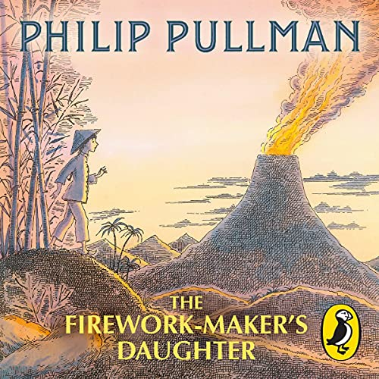 | Umbrella – Short film   | Historical Diary  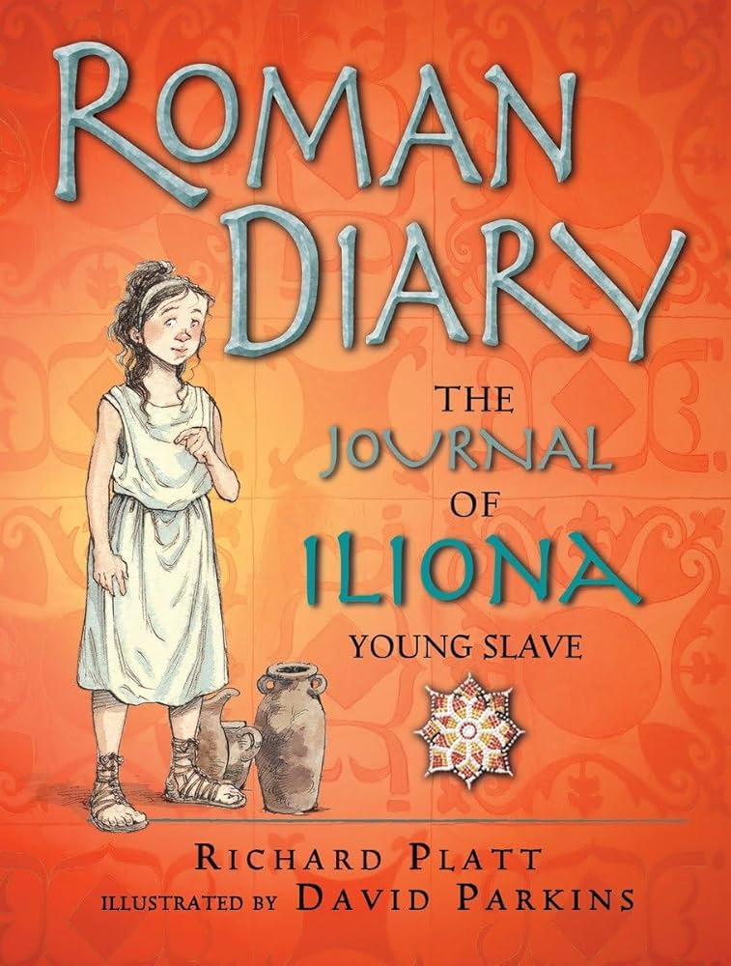
NARRATIVE
NARRATIVE – unit and skills | Adventure stories from other cultures  Writing skills:  (Use prefixes – dis, mis, re and suffixes ly and ous)  - To use nouns, verbs and adjectives to add more detail to writing.  - Read and analyse narrative in order to plan and write their own version.  - To introduce paragraphs.  - Create and develop characters for narrative.  - Improvise, create and write dialogue.  - Generate and select from vocabulary banks.  - To use synonyms for said.  - To begin to use adverbs in dialogue.  - To explore, identify and create complex sentences using a range of conjunctions.  - To introduce adverbs ending in ly. | Imagination story writing  Writing skills:  (Spell homophones and near homophones)  - Create and develop settings for narrative.  - Explore feelings of characters.  - Use inverted commas to punctuate direct speech.  - Create and develop characters.  - Group related material into paragraphs.  - Explore and identify main and subordinate clauses.  - Use different sentence structures.  - To explore adverbs for time and place.  - To explore, identify and create complex sentences using a range of conjunctions.  - To use expanded noun phrases | Narrative diary writing  Writing skills:  (To explore and collect nouns with prefixes – super, anti & auto)  - Create and develop settings for narrative.  - Explore the feelings of characters.  - Group related material into paragraphs.  - Use inverted commas to punctuate direct speech.  - Use the comma to separate clauses in complex sentences where the subordinate clause appears first.  - Create and develop plots based on a model.  - Use different sentence structures.  - To use a range of different adverbs in writing.
Scaffolded Purpose | Purpose: To retell the first chapter of the Firework maker’s daughter. | Purpose: To write part of the animation story from the perspective of the boy. | Purpose: To write a narrative diary entry based on Iliona.
Independent Purpose and Audience | Purpose: To retell the second chapter of the Firework maker’s daughter.  Audience: Read to peers | Purpose: To write part of the animation story from the perspective of the girl.  Audience: Another LKS2 class | Purpose: To write a narrative diary entry from the view point of a Roman slave.  Audience: Upper key stage class
Narrative  Weekly short independent writing opportunities within the unit | - Character profiles  - Finding evidence in the text  - Informal letter  - Firework names – using nouns, verbs and adjectives  - Firework descriptions  - Writing speech | - Writing speech between two characters.  - Setting descriptions  - Story sequencing  - storyboards | - Diary entries  - Mindmaps  - Word banks  - Character descriptions  - Story sequencing
Non-fiction
Non-fiction  Unit and skills | Non-chronological report  Writing skills:  - To explore and use the features of non-chronological reports.  - To collect vocabulary appropriate to the topic.  - To research topic facts.  - To begin to use paragraphs.  - To use a range of conjunctions.  - To use headings and subheadings to sort information. | Persuasive Adverts  Writing skills:  - To explore and use the features of advertisements.  - To use powerful vocabulary.  - To use a range of conjunctions.  - To write in the second person.  - To use rhetorical questions.  - To use adjectives.  - To write descriptions. | Recounts  Writing skills:  - To explore and use the features of recounts  - To write in the first person.  - To write using the past tense.  - To use a range of conjunctions.  - To use interesting adjectives and adverbs.  - To use prepositions.  - To use similes.
Scaffolded Purpose | Purpose: To write a non-chronological report on nocturnal animal | Purpose: To create a persuasive advertisement for an umbrella. | Purpose: To write a recount as a given character
Independent Purpose and Audience | Purpose: To write a non-chronological report on an animal of their choice.  Audience: Read by peers. | Purpose: To create a persuasive advertisement for a product of their choice.  Audience: KS1 Class | Purpose: To write a recount about their school trip.  Audience: KS2 class
Non-Fiction  Weekly short independent writing opportunities within the unit | - Fact files  - Questions  - Spidergrams  - Introductions | - Rhetorical questions  - Poster  - Writing sentences in 2nd and 3rd person  - Building up key phrases and powerful vocabulary | - Glossaries  - Practising similes  - Gathering evidence about Roman soldiers  - Use bullet points to create lists  - Mindmaps
Poetry

Poetry  Unit and skills | Acrostic Poems  Writing skills:  - Word banks  - Building up phrases  - Collecting lists of word classes e.g. Verbs.  - Peer assessment/feedback | Classic Poetry  Writing skills:  - Understanding language used  - Looking for rhyming couplets  - Alliteration | Shape Poems & Calligrams  Writing skills:  - Collect words on a chosen topic
Scaffolded Purpose | Purpose: To write an acrostic firework Poem | Purpose: A child’s thought by Robert Louis Stevenson | Purpose: To create a shape poem and calligram.
Independent Purpose and Audience | Purpose: To write an acrostic poem relating to another curriculum area or current event at the time.  Audience: Other Peer groups in class | Purpose: To write an additional verse for this poem but bringing it into modern day.  Audience: Parents at stay and learn | Purpose: Write their own shape and calligram poem  Audience: KS1 class

