 | AUTUMN | SPRING | SUMMER
CORE TEXT(s) or FILM PIECE | 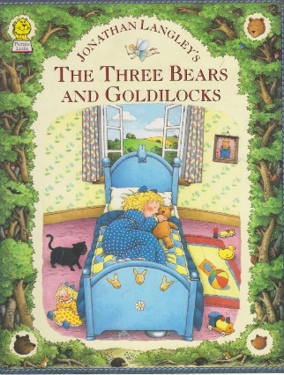 | 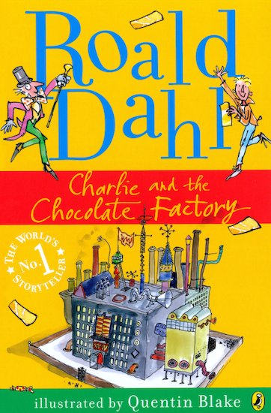 | 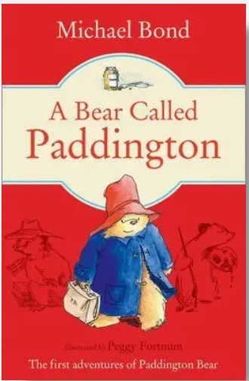  **Film** Snip from the Paddington movie.
NARRATIVE
NARRATIVE – unit and skills | Stories based on a familiar setting  Writing skills:  - Plan and discuss what to write about e.g. story mapping, collecting new vocabulary, key words and ideas.  - Say, write and punctuate simple and compound sentences using the connectives and, but and or.  - Write about real and fictional events.  - Proofread to check for errors in spelling, grammar and punctuation.  - Read aloud their writing with intonation to make the meaning clear.  - Select, generate and effectively use adjectives. | Newspaper Writing  Writing skills:  - Use commas to separate items in a list  - Use suffixes er and est to create adjectives e.g. faster, fastest, smaller, smallest.  - Use suffix ly to turn adjectives into adverbs e.g. slowly, gently, carefully.  - Use apostrophes for contracted forms e.g. don’t, can’t, wouldn’t, you’re, I’ll.  - Say, write and punctuate simple and compound sentences using the connectives and, but and or.  - Proofread to check for errors in spelling, grammar and punctuation.  - Edit and improve their own writing in relation to audience and purpose.  - Write about real and fictional events. | Story Narrative  Writing skills:  - Plan and discuss what to write about e.g. story mapping, collecting new vocabulary, key words and ideas.  - Write about real and fictional events.  - Use subordination for time e.g. When we had finished our writing, we went out to play. We went out to play when we had finished our writing. Other time connectives: while, as, before, after.  - Use subordination for reason e.g. I put my coat on because it was raining. Because it was raining, I put on my coat. Other reason connectives: so, if, then, for, unless.
Scaffolded Purpose | Purpose: To write an innovated story based on a well-known plot and familiar setting. | Purpose: To write a newspaper article retelling part of a story. | Purpose: To write a story based on a story plot created as a class.
Independent Purpose and Audience | Purpose: To write an innovated story based on a well-known story plot and familiar setting.  Audience: To read their story to another class. | Purpose: To write a newspaper article predicting the next part of a story.  Audience: Our parents and carers- via seesaw. | Purpose: To write a story based on a story plot given.  Audience: To make a story book.
Narrative  Weekly short independent writing opportunities within the unit | - retelling the original story.  - Character descriptions  - Wanted poster  - GPS short writing opportunities throughout. | - Newspaper article  - Diary entry  - Character description  - Hot seating questions  - GPS short writing opportunities throughout. | - Predictions on what will happen next  - Diary entry  - post card  - Character description  - GPS short writing opportunities throughout.
Non-fiction
Non-fiction  Unit and skills | Instructions  Writing skills:  - Use subordination for time e.g. When we had finished our writing, we went out to play. We went out to play when we had finished our writing. Other time connectives: while, as, before, after.  - Select, generate and effectively use verbs.  - Use sentences with different forms: statement, question, command, exclamation.  - Use commas to separate items in a list.  - Use specific text type features to write for a range of audiences and purposes e.g. to instruct, inform, entertain, explain, discuss, persuade.  - Use suffix ly to turn adjectives into adverbs e.g. slowly, gently, carefully. | Persuasive leaflet  Writing skills:  - Use present tense for non-chronological reports and persuasive adverts.  - Use sentences with different forms: statement, question, command, exclamation.  - Use apostrophes for contracted forms e.g. don’t, can’t, wouldn’t, you’re, I’ll.  - Use present tense for non-chronological reports and persuasive adverts.  - Use specific text type features to write for a range of audiences and purposes e.g. to instruct, inform, entertain, explain, discuss, persuade.  - Edit and improve their own writing in relation to audience and purpose.  - Use suffixes er and est to create adjectives e.g. faster, fastest, smaller, smallest. | Recount  Writing skills:  - Use subordination for reason e.g. I put my coat on because it was raining. Because it was raining, I put on my coat. Other reason connectives: so, if, then, for, unless.  - Use past tense for narrative, recount (e.g. diary, newspaper report, biography) historical reports.  - Use suffix ly to turn adjectives into adverbs e.g. slowly, gently, carefully.  - Write about real and fictional events.  - Proofread to check for errors in spelling, grammar and punctuation.  - Use specific text type features to write for a range of audiences and purposes e.g. to instruct, inform, entertain, explain, discuss, persuade.
Scaffolded Purpose | Purpose: To write a set of instructions on how to decorate a Christmas tree. | Purpose: To write a leaflet persuading people to visit the chocolate factory. | Purpose: To write a recount on an event that has happened in school.
Independent Purpose and Audience | Purpose: To write their own set of instructions on how to make a disgusting sandwich.  Audience: Share their writing with another class. | Purpose: To write a leaflet persuading people to come to St. Marys school.  Audience: Share with Mrs Wolstenholme. | Purpose: To write a recount on our school sports day.  Audience: Share their writing with another class.
Non-Fiction  Weekly short independent writing opportunities within the unit | - Short writing opportunities for instructions.  - Command sentence writing (Imperative verbs)  - Sentences using commas in a list.  - GPS activities throughout | - Hot seating Willy Wonka (Written Q)  - Thought showers  - Descriptive writing  - GPS activities throughout | - Mind map  - Writing in paragraphs (Sectioning events)  - Ordering events using time conjunctions  - GPS activities throughout
Poetry

Poetry  Unit and skills | Fairy Tale Riddles  Writing Skills:  - Use specific text type features to write for a range of audiences and purposes.  - Use sentences with different forms: statement, question, command, exclamation.  - Write simple poems based on models  - Proofread to check for errors in spelling, grammar and punctuation.  - Read aloud their writing with intonation to make the meaning clear.  - Say, write and punctuate simple and compound sentences using the connectives and, but and or. | Roald Dahl’s the crocodile  Writing Skills:  - Write simple poems based on models.  - Edit and improve their own writing in relation to audience and purpose.  - Read aloud their writing with intonation to make the meaning clear.  - Select, generate and effectively use verbs.  - Select, generate and effectively use nouns.  - Select, generate and effectively use adjectives | Michael Rosen’s Don’t  Writing Skills:  - Write simple poems based on models.  - Edit and improve their own writing in relation to audience and purpose.  - Read aloud their writing with intonation to make the meaning clear.  - Use apostrophes for contracted forms e.g. don’t, can’t, wouldn’t, you’re, I’ll.  - Select, generate and effectively use verbs.  - Select, generate and effectively use nouns.
Scaffolded Purpose | Purpose: To write a riddle about a fairy tale character. | Purpose: To write a new verse for ‘The Crocodile’ following the 8 syllables pattern. | Purpose: To write the next verse based on a model.
Independent Purpose and Audience | Purpose: To write a riddle about themselves.  Audience: Our class- Guessing game! | Purpose: To innovate a familiar poem based on a model.  Audience: To perform and video this to send home (Seesaw). | Purpose: To innovate a poem based on a model.  Audience: To perform their poems to the class.

