= | AUTUMN | SPRING | SUMMER
CORE TEXT(s) or FILM PIECE | 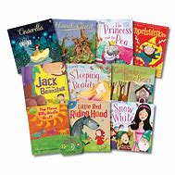  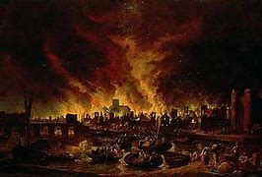 | 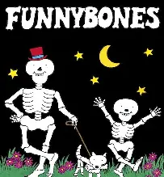  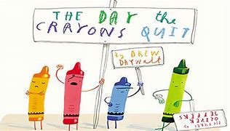 |   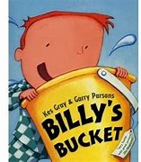
NARRATIVE
NARRATIVE – unit and skills | Fairy Tales  Writing skills:  - Orally compose every sentence before writing.  - Reread every sentence to check it makes sense.  - Punctuate simple sentences with capital letters and full stops.  - Use simple connectives to link ideas e.g. and, but, or, so.  - Use the personal pronoun ‘I’  - Say, and hold in memory whilst writing, simple sentences which makes sense.  - Sequence events in order.  - Select, generate and effectively use adjectives.  - Use formulaic phrases to open and close texts.  - Compose and sequence my own sentences to write short narratives.  - Form lowercase letters correctly.  - Form capital letters correctly.  - Use past tense for a narrative | Stories by the same author  Writing skills:  - Sequence ideas and events in non-fiction.  - Use familiar plots for structuring the opening, middle and end of their stories.  - Write simple sentences that can be read by themselves and others.  - Sequence events in order.  - Identify and use exclamation marks.  - Use simple connectives to link ideas e.g. and, but, or, so.  - Use apostrophes for contracted forms e.g. don’t, can’t, wouldn’t, you’re, I’ll.  - Form lowercase letters correctly.  - Form capital letters correctly.  - Use past tense for a narrative | Fantasy Stories  Writing skills:  - To create a draft of my own bucket story.  - To edit and improve my story with a partner, acknowledging feedback.  - Use simple connectives to link ideas e.g. and, but, or, so.  - To write my own story using exclamation marks, conjunctions and commas when needed.  - Use commas to separate items in a list.  - Select, generate and effectively use adjectives.  - Use formulaic phrases to open and close texts.  - To use capital letters for nouns.  - Pluralise nouns using ‘s’ and ‘es’  - Add suffixes to verbs.
Scaffolded Purpose | Purpose:  To re-tell the story of Jack and The Beanstalk. | Purpose:  To write a chapter of a ‘Funny Bones’ story. | Purpose:  To retell the story of Billy’s Bucket.
Independent Purpose and Audience | Purpose:  To retell the story of Jack and The Beanstalk with a new character.  Audience: Read to peers. | Purpose:  To write my own ‘Funny Bones’ story.  Audience: Seesaw to parents. | Purpose:  To retell the story of Billy’s Bucket innovating a new ending.  Audience: English Lead
Narrative  Weekly short independent writing opportunities within the unit | - Character descriptions  - Diary entries  - Story maps, including both text and pictures.  - Wanted poster of the Giant.  - Draft writing of the beginning of the story of Jack and The Beanstalk. | - Character profiles  - To answer, who, what, where (etc) questions  - Setting descriptions  - Story map, sequencing the story using both text and picture. | - Character descriptions  - Lists of ideas for Billy then creating short paragraphs with these ideas.  - Diary entry from Billy and how he felt on his birthday.
Non-fiction
Non-fiction  Unit and skills | Diary Entries  Writing skills:  - Use connectives (next, after that)  - Finger spaces and full stops.  - Capital letters for names.  - The correct spellings for the days of the week.  - Form lowercase letters correctly.  - Form capital letters correctly.  - Use present tense for a non-chronological report.  - To include exclamation marks, conjunctions and commas when needed. | Persuasion  Writing skills:  - To use conjunctions in my writing (but, because, and, so)  - To be able to reread my sentences and edit if needed.  - To write letters and postcards using key features.  - How to layout a letter  - Informal and formal letters  - How to write a postcard and the difference between letter and postcard.  - Write a letter to Duncan, discussing why he needs them back.  - To include exclamation marks, conjunctions and commas when needed.  - Select, generate and effectively use nouns.  - Pluralise nouns using ‘s’ and ‘es’  . | Instructions  Writing skills:  - Write simple sentences that can be read by myself and others.  - Punctuate simple sentences with capital letters and full stops.  - Reread every sentence to check it makes sense.  - Orally plan and rehearse ideas.  - Sequence ideas in order.  - Write in different forms with simple text features e.g. instructions.  - To include exclamation marks, conjunctions and commas when needed.  - Read aloud their writing to adults and peers.  - Select, generate and effectively use verbs.  - To use the present tense
Scaffolded Purpose | Purpose:  To create a diary entry about The Great Fire of London from Vlad’s perceptive. | Purpose:  To write a persuasive letter from Duncan to a crayon. | Purpose:  To write a small set of instructions on how to brush your teeth.
Independent Purpose and Audience | Purpose:  To create a diary entry from Thomas Farriner’s perceptive.  Audience: Show another KS1/EYFS class. | Purpose:  To write a persuasive letter from a crayon to Duncan.  Audience: Peers. | Purpose:  To write instructions on how to make a tie-dye t-shirt.  Audience: Head teacher
Non-Fiction  Weekly short independent writing opportunities within the unit | - Character descriptions  - Event planning of The Great Fire of London.  - Draft of newspaper report. | - Diary entries  - Post cards  - Character descriptions | - Posters  - Setting descriptions  - Leaflet comparisons in books.
Poetry
Poetry  Unit and skills | Sense poems  Writing skills:  - To be able to describe what happens for each sense.  - To participate in a class sense poem.  - To describe each sense relating to the Great Fire.  - To draft my own poem about The Great Fire.  - To use adjectives to describe the fire. | Acrostic poems  Writing skills:  - To use expanded noun phrases.  - To use adjectives to describe what is happening in pictures relating to Spring.  - To draft a poem.  - To edit and improve. | Kennings poems  Writing skills:  - Draft and write by noting ideas, key phrases and vocab, composing and rehearsing sentences orally.  - Reread and evaluate writing to check it makes sense and make simple revisions.  - Read writing aloud with appropriate intonation to make the meaning clear.  - Use new and familiar punctuation correctly.
Scaffolded Purpose | Purpose:  To create a sense poem about The Great Fire of London as a class. | Purpose:  To create a class acrostic poem about Spring. | Purpose:  To create a class Kennings poem based on the story ‘One Day on Our Blue Planet.’
Independent Purpose and Audience | Purpose:  To create an independent sense poem about The Great Fire of London.  Audience: Seesaw videos to parents. | Purpose:  To write their own acrostic poem about Spring.  Audience: Share with another KS2 class. | Purpose:  To write their own Kennings poem using the book, ‘One Day on Our Blue Planet.’  Audience: Read to peers.

