 | AUTUMN | SPRING | SUMMER
CORE TEXT(s) or FILM PIECE | 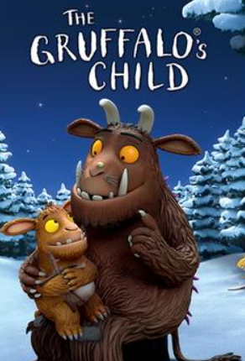  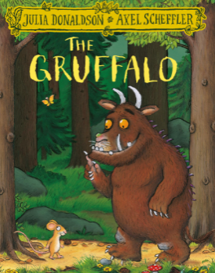 | 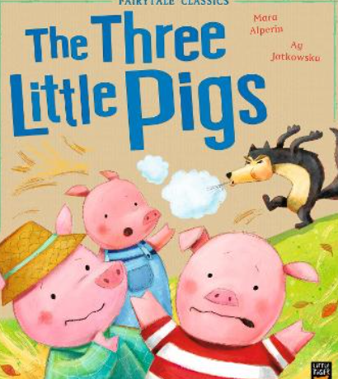 | TBC  Film!
NARRATIVE
NARRATIVE – unit and skills | Character description  Writing skills:  - Say, and hold in memory whilst writing, simple sentences which make sense.  - Write simple sentences that can be read by themselves and others.  - Separate words with spaces.  - Use the joining word and to link words and clauses.  - Use punctuation to demarcate simple sentences (capital letters and full stops).  - Identify and use question marks and exclamation marks.  - Use effective nouns, verbs and adjectives  - Form lower-case and upper-case letters correctly | Fairy tale (3 Little pigs)  Writing skills:  - Say, and hold in memory whilst writing, simple sentences which make sense.  - Write simple sentences that can be read by themselves and others.  - Separate words with spaces.  - Use the joining words and/but/or  - Use capital letters for names of people, places and days of the week.  - Use punctuation to demarcate simple sentences (capital letters and full stops).  - Identify and use question marks and exclamation marks.  - Use effective nouns, verbs and adjectives  - Add the prefix ‘un’ to verbs and adjectives to change the meaning e.g. untie, unkind.  - Orally compose every sentence before writing.  - Re-read every sentence to check it makes sense.  - Compose and sequence their own sentences to write short narratives.  - Use formulaic phrases to open and close texts.  - Spell words using the 40+ phonemes already taught, including making phonically plausible attempts at more complex words. | TBC  Writing skills:  - Use formulaic phrases to open and close texts.  - Spell words using the 40+ phonemes already taught, including making phonically plausible attempts at more complex words.
Scaffolded Purpose | Purpose: To write a class character description of The Gruffalo | Purpose: To re-tell the story of the 3 little pigs. | Purpose: To write a
Independent Purpose and Audience | Purpose: To write a character description of The Gruffalo’s child  Audience: Parents on Seesaw. | Purpose: To re-tell the story of the 3 little pigs changing what the houses are built from.  Audience: Another KS1 class. | Purpose: To write a  Audience: Mrs Wolstenholme.
Narrative  Weekly short independent writing opportunities within the unit | - Sentences describing the Gruffalo  - Generating adjectives and putting them into a sentence  - Labelling pictures of Gruffalo | - Write speech bubbles of conversation between pigs and wolf  - Practise writing opening of story  - Write sentence openers  - Diary entry as one of the Pigs  - Wanted poster for Big Bad Wolf
Non-fiction
Non-fiction  Unit and skills | Instructions  Writing skills:  - Use formulaic phrases to open and close texts.  - Compose and sequence their own sentences to write short non-fiction texts, e.g. recounts, information texts, instructions.  - Correctly use capital letters, full stops, question marks and exclamation marks  - Use finger spaces  - Make singular nouns plural using ‘s’ and ‘es’ e.g. dog, dogs; wish, wishes.  - Use effective nouns, verbs and adjectives  - Extend range of joining words to link words and clauses using but and or.  - Orally compose every sentence before writing.  - Re-read every sentence to check it makes sense. | Persuasive letter Writing  Writing skills:  - Say, and hold in memory whilst writing, simple sentences which make sense.  - Write simple sentences that can be read by themselves and others.  - Separate words with spaces.  - Correctly use capital letters, full stops, question marks and exclamation marks  - Use capital letter for the personal pronoun I.  - Correctly use capital letters, full stops, question marks and exclamation marks  - Add suffixes to verbs where no spelling change is needed to the root word e.g. helping, helped, helper.  - Use effective nouns, verbs and adjectives  - Add the prefix ‘un’ to verbs and adjectives to change the meaning e.g. untie, unkind.  - Extend range of joining words to link words and clauses using but and or. | Recount  Writing skills:  - Spell words using the 40+ phonemes already taught, including making phonically plausible attempts at more complex words.  - To use time openers e.g. First, Next  - Write simple sentences that can be read by themselves and others.  - Separate words with spaces.  - Use capital letter for the personal pronoun I.  - Correctly use capital letters, full stops, question marks and exclamation marks  - Add suffixes to verbs where no spelling change is needed to the root word e.g. helping, helped, helper.  - Use effective nouns, verbs and adjectives  Extend range of joining words to link words and clauses using but and or.
Scaffolded Purpose | Purpose: To write a class set of instructions for making apple crumble | Purpose: To write a persuasive letter to a builder as the little pig. | Purpose: To write a class recount about an event in school.
Independent Purpose and Audience | Purpose: To write a set of instructions for how to make Gruffalo crumble.  Audience: Peers in class. | Purpose: To write a persuasive letter to the wolf asking him to be kinder.  Audience: Share with Miss Quinn (English Lead). | Purpose: To write a recount on a class trip.  Audience: Share on Seesaw.
Non-Fiction  Weekly short independent writing opportunities within the unit | - Create a list of ingredients using adjectives  - Improve and re-write a set of instructions  - Make a set of instructions longer with use of joining words  - Add punctuation into a set of instructions | - List the ways wold if being unkind  - Create a list of reasons to why the wolf should be kinder  - Extend sentences with joining words to make them more detailed  - Practise writing the opening to their letter | - Sentences describing how they felt during different times of the trip  - Sentences with time openers to order the trip  - To improve some sentences by adding adjectives and joining words  - To create a plan for our recount
Poetry

Poetry  Unit and skills | Acrostic poems (Christmas)  Writing Skills:  - Say, and hold in memory whilst writing, simple sentences which make sense.  - Write simple sentences that can be read by themselves and others.  - Separate words with spaces.  - Use punctuation to demarcate simple sentences (capital letters and full stops).  - Use effective nouns, verbs and adjectives  - Form lower-case and upper-case letters correctly | ‘Spring is’ Poems  Writing Skills:  - Say, and hold in memory whilst writing, simple sentences which make sense.  - Write simple sentences that can be read by themselves and others.  - Separate words with spaces.  - Use punctuation to demarcate simple sentences (capital letters and full stops).  - Use effective nouns, verbs and adjectives  - Form lower-case and upper-case letters correctly  - Extend range of joining words to link words and clauses using but and or.  - Form lower-case and upper-case letters correctly | Sense poems (School)  Writing Skills:  - Spell words using the 40+ phonemes already taught, including making phonically plausible attempts at more complex words.  - Correctly use capital letters, full stops, question marks and exclamation marks  - Add suffixes to verbs where no spelling change is needed to the root word e.g. helping, helped, helper.  - Use effective nouns, verbs and adjectives  - Form lower-case and upper-case letters correctly
Scaffolded Purpose | Purpose: To write a class poem acrostic poem about Christmas. | Purpose: To write a class Spring is poem. | Purpose: To write a whole-class sense poem about school
Independent Purpose and Audience | Purpose: To write an independent acrostic poem about Christmas.  Audience: Reception class. | Purpose: To write an independent ‘Spring is’ poem.  Audience: Parents via Seesaw. | Purpose: To write an independent sense poem about school.  Audience: Year 6.

