 | AUTUMN | SPRING | SUMMER
CORE TEXT(s) or FILM PIECE | 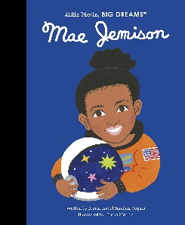  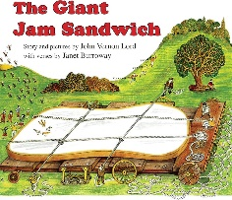  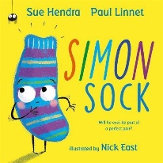  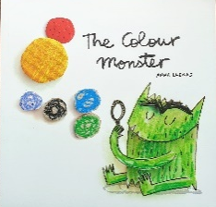  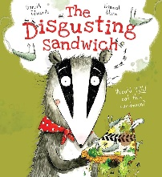  https://www.youtube.com/watch?v=cwZb2mqId0A-  https://www.youtube.com/watch?v=rWxGAogqr4M -Mae Jemison | 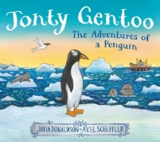  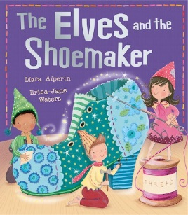  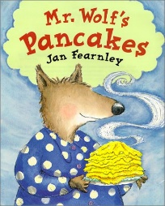  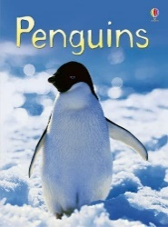  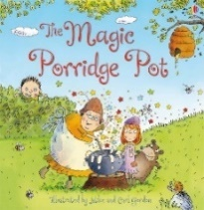  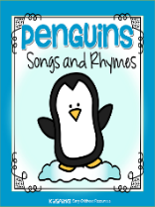  https://youtu.be/woCIpMyyjxw - Penguins (David Attenborough) | 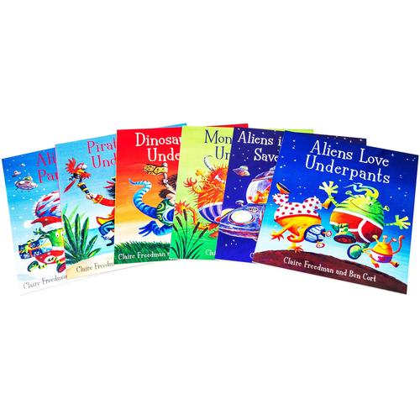  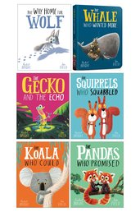  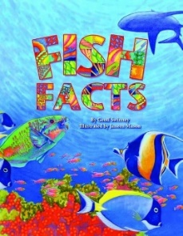  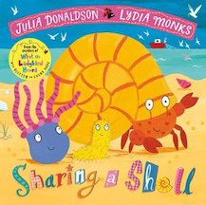  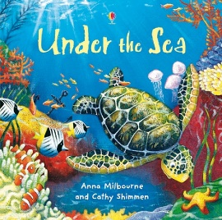  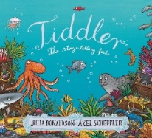  https://www.youtube.com/watch?v=GC_mV1IpjWA - The little Mermaid (short animation clip
ELG SKILLS
 | Reading:  - Understand key concepts about print:  - print has meaning  - print can have different purposes  - we read English text from left to right and from top to bottom  - the names of the different parts of a book  - page sequencing  - Develop their phonological awareness through Red Rose Phonics.  Writing:  - Use some of their print and letter knowledge in their early writing.  - Write some or all of their name.  - Write the handwriting patterns to support cursive script  Communication and language:  - listen attentively and respond to what they hear with relevant questions, comments, and actions when being read to, and during whole class discussions and small group interactions;  - make comments about what they have heard and ask questions to clarify their understanding  - demonstrate understanding of what has been read to them by retelling stories and narratives using their own words and recently introduced vocabulary;  - anticipate, where appropriate, key events in stories;  - use and understand recently introduced vocabulary during discussions about stories and during role-play. | Reading:  - Read a few common exception words matched to the Red Rose Phonics  - Read simple phrases and sentences made up of words with known letter–sound correspondences and where necessary tricky words.  - Re-read these books to build up their confidence in word reading, their fluency and their understanding and enjoyment.  Writing:  - Form some lower-case and capital letters correctly.  - Spell words by identifying the sounds and then writing the sound with letter/s.  - Write short sentences with words with known sound-letter correspondences using a capital letter and full stop.  - Re-read what they have written to check that it makes sense.  Communication and language:  - participate in small groups, class and one-to-one discussions, offering their own ideas, using recently introduced vocabulary;  - offer explanations for why things might happen, making use of recently introduced vocabulary from stories, non-fiction, rhymes, and poems when appropriate;  - express their ideas and feelings about their experiences using full sentences, including use of past, present, and future tenses and making use of conjunctions, with modelling and support from their teacher. | Comprehension-Children at the expected level of development will:  - demonstrate understanding of what has been read to them by retelling stories and narratives using their own words and recently introduced vocabulary;  - anticipate, where appropriate, key events in stories;  - use and understand recently introduced vocabulary during discussions about stories, non-fiction, rhymes, poems, and during role-play.  Reading: Children at the expected level of development will:  - say a sound for each letter in the alphabet and at least 10 digraphs;  - read words consistent with their phonic knowledge by sound-blending;  - read aloud simple sentences and books that are consistent with their phonic knowledge, including some common exception words.  Writing: Children at the expected level of development will:  - write recognisable letters, most of which are correctly formed;  - spell words by identifying sounds in them and representing the sounds with a letter or letters;  - write simple phrases and sentences that can be read by others.

